Apreo SEM - EDAX
SEM should be ready to image:
Set kV to 20 kV, and Beam current 0.8nA, Sample at 10 mm, focused (check z = 10mm),
good contrast/brightness, magnification

1. Turn on EDAX computer
2. Insert EDAX probe
3. Log in under EDAX; Username = user, Password = user

4. Click on APEX EDS short cut – if it fails to connect restart EDAX computer, if it still doesn’t connect contact FMIC staff

5. Project window comes up – select from ‘Recent list’ or ‘Create’ Save to (or make) your folder in EdaxData(E:) FMIC user data
6. Click on DETECTOR COOLING ICON 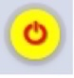 (Yellow circle next to camera)

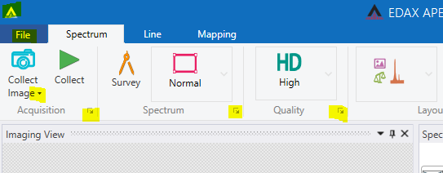
8
7

7. Wait for it to turn into green triangle in the Acquisition box on the COLLECTION TOOLBAR. The detector should be ready in about 3 – 4 minutes.

8. Click on the down arrow next to the words “Collect Image” to select Scanning resolution so that it matches the SEM (as close as possible)
9. Unpause Imaging Quadrant on SEM
10. Pause sample chamber view
11. Click on Camera icon to collect image -
12. Choose Spectrum, Line or Mapping from the top word menu
13. To “select”, “deselect” or “force ID” of an element click on “Modify element list” icon in the icon list on the Spectrum window
14. “Project Tree” can be found by clicking on the small triangle in the top left corner of the app
15. “Return to live mode” can be found top right corner of the app

Spectrum Mode:
- Choose collection style; “Normal”, “Free Draw” or “Grid” tool
- Normal click on area of interest to choose that spot
- Free Draw draw line around area of interest
- Grid draw a box and select how many configuration points, click “Confirm” or “Remove”
- Click on green triangle to collect data
Line Mode
- Click and drag on image to select linescan area
- Select Quick, Standard (SD), High(HD), manual
- Linescan parameters can be changed by clicking on small symbol in Quality box

Mapping Mode
Click on Mapping box and size, dwell and duration of mapping appear
Click on small box bottom of mapping tab to adjust Mapping Parameters

Name projects and Create Report
- To name or rename data in Project tree
- Select/highlight item of interest
- Click on T
- Delete current name
- Type in new name

Create report
- Double click on data of interest in Project tree: New menu bar pops up
- Selectable Report – White Box “Generate” shows only the selected image and data, excludes the deselected elements
- Quick Report – Green Circle “Generate” shows all elements available in sample including deselected elements and errors
- Click on Save (upper left corner) and select save method from drop down menu
- Click on “Switch to live mode” (upper right corner) to continue collecting data
Notes:

- If Quanta data for any element is RED, there was an error. Rerun again if it recurs use “Lock Elements” to remove them from data. To create report without erroneous elements, remove them from results and use “Selectable Report”.

- To show “Project Tree” click on both “Control” and “A” to show

End of Session
1. Collect your data – data will be deleted otherwise (info/files stored in “E” drive PCEdaxData (E:)FMIC User dataUser Data)

2. Exit EDAX program, Turn off EDAX computer
3. Pause Image
4. Beam Off
5. Home Stage
6. Remove Probe - remove probe before venting to prevent damage to probe
7. Vent
8. Remove samples
9. Push door shut, select “High Vacuum”, click on “Pump” then WAIT to be sure chamber has pumped out and is under vacuum before you leave

