Bacteria - LRW Immuno Fix & Embed
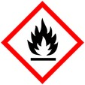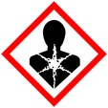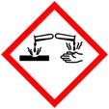
Protective Equipment; Safety glasses, Lab coat, gloves and Chemical Fume hood

Remember to label all vials with; sample name, fixative type, your name & date

Fixation: 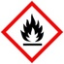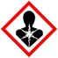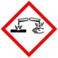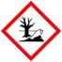1.25% Glutaraldehyde/2% Paraformaldehyde
in 100mM buffer* Overnight at 4°C
Rinse: 0.1 M buffer 3x 10 mins each

Dehydration: 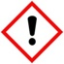
30% Ethanol 10 mins
50% Ethanol 10 mins
60% Ethanol 10 mins
70% Ethanol 10 mins
80 % Ethanol 10 mins
95% Ethanol 10 mins

Infiltration: 95% Ethanol: LR White 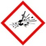
1:1

100% LR White 2x overnight each change

Embedding: LR White in gelatin capsules,epindorf tubes or other O₂ excluding molds

- or use vacuum oven (check for correct temp (60 -65° C or 140 – 149° F)

Curing: Overnight in oven

* Phosphate or Cacodylalte

