TEM Bacteria Morphological Fixation

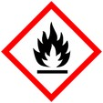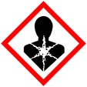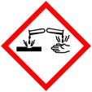

**Protective Equipment**; Safety glasses, Lab coat, gloves and Chemical Fume hood

Remember to **label all vials** with; sample name, fixative type, your name & date

Primary Fixation:

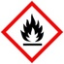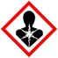

2- 4% Paraformaldehyde/2% - 3% Glutaraldehyde Overnight, 4° C

in 0.1 M Phosphate

and/or

Microwave fix (**optional**) - 2.5 minutes, Power: 250 W, Cut off temp 28° C

2 % Paraformaldehyde/2 % Glutaraldehyde

in 0.1 M buffer

Rest at room temperature 5 minutes

Rinse: With buffer 3x 5 – 10 min ea

Secondary fixation: Osmium tetroxide (1-2%) 2% -1h room temp (r.t.),

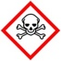

Or 1% - overnight 4° C

Rinse: With ddH2O after OsO4 3x 5 -10 mins each

Dehydration:



30% Alcohol 10 mins

50% Alcohol 10 mins

70% Alcohol 10 mins

95% Alcohol 10 mins

100% Alcohol 3x, 10 mins ea

100% Propylene Oxide 1x, 10 mins



Infiltration: SPURRS: Propylene Oxide



1 : 1 1 hr to overnight

100% SPURRS in hood **3x**

**Warning**: Don’t leave samples in 100% SPURRS for more than one night at room temperature as polymerization may occur.

Embedding: Change resin just before embedding in molds. Place paper label in mold, then sample

Curing/Polymerization: Overnight in oven in hood.