Grid staining (positive stain for sections)

Protective Equipment; Safety glasses, Lab coat, gloves and Chemical Fume hood

1. Uranyl Acetate (UA) – caution; light sensitive 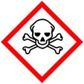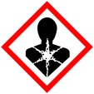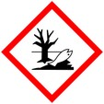
- Draw UA up into syringe (1 – 2 ml), careful not to touch bottom of bottle or suck up precipitate
- Put filter on tip of syringe and fill microfuge tube with UA
- Draw UA up into staining tube, cover with aluminum foil or amber bottle
- 5 -15 minutes Uranyl Acetate*
- Rinse ddH₂O – 3 clean glass beakers up and down ~20 x each beaker

Dry or do not dry** between stains – depends on sample and experience

2. Reynolds Lead – caution; reacts with CO₂ 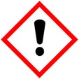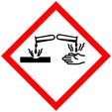
- Draw Reynolds lead up into syringe (1 – 2 ml)
- Rinse grids with 0.1 N NaOH to remove CO₂
- Draw up Reynolds lead
- 3 -15 minutes in Reynolds Lead*
- Rinse grids with 0.1 N NaOH to remove CO₂
- Rinse ddH₂O – 3 clean glass beakers up and down ~20 x each beaker

3. Drying
- Remove grid stick from staining pipet and place under heat light for ~5 minutes, the longer grids are on the stick the harder it is to remove them
- Remove grids from grid stick and place in grid box, put in desiccator until ready to use

*staining times are dependent on your sample

** Hayat, M.A. (1989) Principles and Techniques of Electron Microscopy, second ed. (pg.317)

Lead stain time increased if using coated grids, very thin sections and thicker sections (p.314)

Lead precipitates may be removed by exposing the sections to 10% acetic acid for 1min

