Standard SEM Sample Preparation
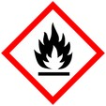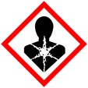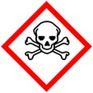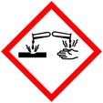

Procedure for fixation and dehydration of samples for Scanning Electron Microscopy
Protective Equipment; Safety glasses, Lab coat, gloves and Chemical Fume hood

Remember to label all vials with; sample name, fixative type, your name & date

Primary Fixation: 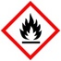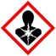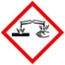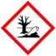
2- 4% Paraformaldehyde/2% - 3% Glutaraldehyde Overnight, 4° C
in buffer*
Rinse: With buffer 3x 5 – 10 min ea

Secondary fixation (optional):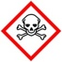
Osmium tetroxide (1-2%) 2% -1h room temp (r.t.),
Do not use PIPES buffer with Osmium Or 1% - overnight 4° C

Rinse: With ddH2O after OsO₄ 3x 5 -10 mins each

(If freeze dring after ddH20 rinses - See freeze dry protocol and contact staff for help)

Dehydration:
30% Ethanol 10 mins, r.t.
50% Ethanol 10 mins, r.t.
70% Ethanol 10 mins, r.t.
90% Ethanol 10 mins, r.t.
100% Ethanol 3x, 10 mins ea, r.t.

Final Drying options;
- check with staff for which procedure applies and for help/training.
- Freeze dry 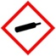– immediately after water rinses, do not dehydrate with ethanol
- HMDS - animal & microbial samples
- CPD (critical point dry – plant, animal, microbial

*Buffers - The buffer used in the fixative is determined by the tissue type.
The most commonly used buffers in our lab are the following;
0.05 M PIPES buffer (usually used with plant tissues)
0.1 M Phosphate buffer
0.2 M Cacodylate buffer

