Bacteria or Tissue Cultured Cell SEM Sample Preparation
(Tissue Cultured Cells in microfuge tubes)
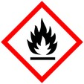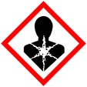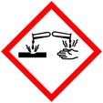
Procedure for fixation and dehydration of samples for Scanning Electron Microscopy
Protective Equipment; Safety glasses, Lab coat, gloves and Chemical Fume hood

Remember to label all vials with; sample name, fixative type, your name & date

Fixation: 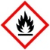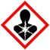
2% Paraformaldehyde /2-3% Glutaraldehyde in buffer* Overnight, 4° C

and/or
Microwave fix (optional) - 2.5 minutes, Power: 250 W, Cut off temp 28° C
2 % Paraformaldehyde/2 % Glutaraldehyde

Rest at room temperature 5 minutes

Rinse: With buffer 3x 5 – 10 min ea

Post Fix: 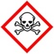
1 - 2% OsO₄ in ddH₂O 2 hr, rt or
overnight at 4° C

Rinse: ddH₂O 3x 5 min

Dehydration:
30% Ethanol 10 mins
50% Ethanol 10 mins
70% Ethanol 10 mins
95% Ethanol 10 mins
100% Ethanol 3x, 10 m ea

100 % HMDS - 2x, 10 m

Final Drying:
- Pipet sample/HMDS mix onto glass coverslip on SEM stub and let air dry in hood
- Or leave sample in vial/tube & pipette out most of the HMDS (leave just enough to cover sample).
- Let air dry in fume hood.

