SEM – Microwave Fix and Dehydration
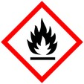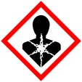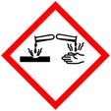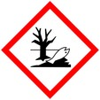

Protective Equipment; Safety glasses, Lab coat, gloves and Chemical Fume hood
Remember to label all vials/tubes with; sample name, fixative type, your name & date

Solution preparation:
All solutions on ice prior to microwaving - 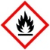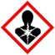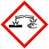 (fixatives and buffers)

For plants; For animals;
Fixative; Fixative;
2% PFA 2% PFA
2% Glut 2% Glut
0.05 M PIPEs 0.1 M Phosphate or Cacodylate buffer

Ethanol Dehydration series; 30%, 50 %, 60 %, 70%, 80%, 90%, 100%

Sample preparation:
Dissections should occur prior to fixation

Prepare dummy tube for temperature probe place on ice until ready to use

Epindorf tubes 600 µl fixative - for small samples (1-5 mm). Do not put more than 3 samples in each tube
Scintillation vial approx. 1 ml fixative (samples over 5 mm). Do not crowd samples in vial

Fix;
Place containers and dummy tube in rack in ice bath (= ice + water), place in microwave
2min 30 sec, 250 - 750 Watts, Cut off temp 30° C
- Remove from microwave and rest at room temperature for 5 minutes

Rinse;
Buffer 2x, 5 min ea
ddH₂O 1x, 5min
samples may be transferred from tubes to baskets in divided petri plate if desired.

Dehydration; Ethanol
30%, 50 %, 60 % - 1x 40 sec each step
70%, 80%, 90%, 100% - 2x, 40 sec each step

after microwave replace ethanol with fresh 100%, can be stored overnight at room temp prior to critical point drying

Notes;
if you have a specific protocol requiring another fixative use what is recommended

