Hexamethyldisilizane (HMDS) SEM Sample Prep
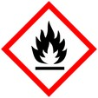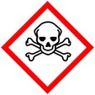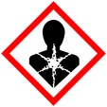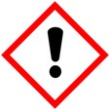
Chemical (HMDS) drying of samples for scanning electron microscopy observation

Protective Equipment; Safety glasses, lab coat, gloves and Chemical Fume hood

HMDS 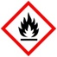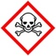is a final drying step for samples intended for the SEM, use after fixation and dehydration protocols. It is highly volatile and hazardous – read MSDS and all warnings before use.

The amount of time for each step can range from 5 - 20 minutes or more. If samples are very small (i.e. single cell organisms) then use the shorter times, as size and complexity increase, also increase the time in each solution. You may need to experiment with this procedure to produce the best results for your samples.

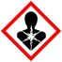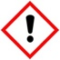 100% EtOH 10 minutes
100% HMDS 10 – 30 minutes (depends on sample density)
100% HMDS just enough to cover sample, leave overnight in hood

Tissues may be left in original containers . It can be difficult to get bacteria or small particles out of tubes due to static or small sample size, in this case it is better to pipette onto small round coverslips attached to SEM stubs.

Let air dry in fume hood overnight longer if necessary .
After mounting, place in vacuum dessicator to avoid contaminating the sputter coaters.
Samples smaller than 10 mm vacuum dessicate for 10 minutes
Samples larger than 10 mm vacuum dessicate for 15 – 30 minutes

