Plant - LR White Morphological fix & embed

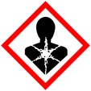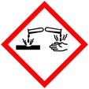

Procedure for fixing and embedding plant tissue with LR White for morphological study

**Protective Equipment**; Gloves, lab coat, fume hood and safety glasses.

Remember to **label all vials** with; sample name, fixative type, your name & date

Primary Fixation:



2- 4% Paraformaldehyde/ 2% - 3% Glutaraldehyde Overnight, 4° C

in 0.05 M Phosphate or PIPEs buffer

Rinse: With buffer 3x 5 – 10 min ea

Warning: Osmium tetroxide causes uncontrolled polymerization when used with LRW, contact staff for more information if needed

Dehydration:



30% Ethanol 10 mins

50% Ethanol 10 mins

60% Ethanol 10 mins

70% Ethanol 10 mins

80% Ethanol 10 mins

95% Ethanol 10 mins

100% Ethanol 3x, 10 mins each

Infiltration: (LRW Teratogen)

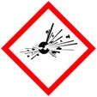

LR White : Ethanol

1 : 3 each step overnight

1 : 2

1 : 1

3 : 1 (optional step, depends on tissue density)

100% LR White overnight, in hood or rotary table 3x

Embedding: LR White in gelatin capsules or other O2 excluding mold, place label in mold then sample

Curing: Overnight in oven at 60 - 65**°** C

- or use vacuum oven (check for correct temp (60 -65**°** C or 140 – 149**°** F)