Plants - LRW Immuno Fix & Embed

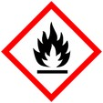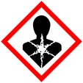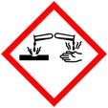

Procedure for fixing and embedding plant tissue with LR White for immunolocalization

**Protective Equipment**; Safety glasses, Lab coat, gloves and Chemical Fume hood

Remember to **label all vials** with; sample name, fixative type, your name & date

Fixation: 1.25% Glutaraldehyde/2% Paraformaldehyde

in 50mM Pipes buffer Overnight at 4 °C

Rinse: 50mM Pipes buffer 3x 10 mins each

Warning: Osmium tetroxide causes uncontrolled polymerization when used with LRW, and can interfere with antigen recognition by antibodies. Contact staff for more information if needed

Dehydration:

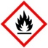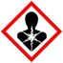

30% Ethanol 10 mins

50% Ethanol 10 mins

60% Ethanol 10 mins

70% Ethanol 10 mins

Samples may begin infiltration with LRW resin at this point if needed

80% Ethanol 10 mins

95% Ethanol 10 mins

100% Ethanol 2x, 10 mins ea

Infiltration:

LR White : Ethanol In hood, each step overnight

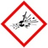

1 : 3

1 : 2

1 : 1

3 : 1 (optional step, depends on tissue density)

100% LR White 3-4x overnight each change

Embedding: LR White in 2 small plastic cups, gelatin capsules or other O2 excluding molds

- or use vacuum oven (check for correct temp (60 -65**°** C or 140 – 149**°** F)

Curing: Antigenicity may be compromised if samples are cured at temps higher than 55° C. Overnight in oven