Animal Morphology- SPURRS

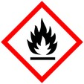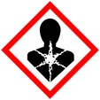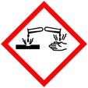

Procedure for fixing and embedding animal tissue with SPURRS

**Protective Equipment**; Safety glasses, Lab coat, gloves and Chemical Fume hood

Remember to **label all vials** with; sample name, fixative type, your name & date

1°Fixation:

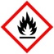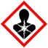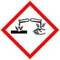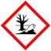

2- 4% Paraformaldehyde/2% - 3% Glutaraldehyde Overnight, 4° C

in 0.1 M Phosphate

Rinse: With buffer 3x 5 – 10 min ea

Secondary fixation(optional):

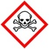

Osmium tetroxide (1-2%) 2% -1h room temp (r.t.),

Or 1% - overnight 4° C

Rinse: With ddH2O after OsO4 3x 5 -10 mins each

Dehydration:



30% Ethanol 10 mins

50% Ethanol 10 mins

70% Ethanol 10 mins

95% Ethanol 10 mins

100% Ethanol 10 mins, 3x

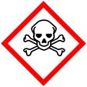

100% PO 2x, 10mins ea

Infiltration: :



PO : SPURRs

1 : 1 1 h to overnight

100% SPURRs 1 h to overnight

Embedding: Change resin prior to embedding

Don’t leave sample in SPURRs (without changing) for more than one night as polymerization may occur. Change resin just before embedding in flat molds.

Polymerization/Curing: Overnight in oven

**Warning**: Don’t leave samples in 100% SPURRS for more than one night at room temperature as polymerization may occur.