Animal Morphology- LRW

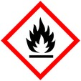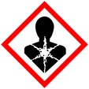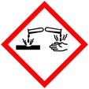

Procedure for fixing and embedding animal tissue with LR White

(Not For Immmunolocalization)

**Protective Equipment**; Safety glasses, Lab coat, gloves and Chemical Fume hood

Remember to **label all vials** with; sample name, fixative type, your name & date

Primary Fixation:

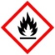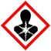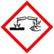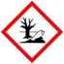

2- 4% Paraformaldehyde/2% - 3% Glutaraldehyde Overnight, 4° C

in 0.1 M Phosphate

Rinse: With Buffer 3x, 5 – 10 min ea

Dehydration:

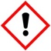

30% Ethanol 10 mins

50% Ethanol 10 mins

70% Ethanol 10 mins

95% Ethanol 10 mins

100% Ethanol 3x, 10 m ea

Infiltration: :

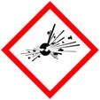

LR White : Ethanol

1 : 1 1 hour to overnight

100% LR White 1 h to overnight

Embedding: LR White in gelatin capsules or other O2 excluding mold, place label in mold then sample

Curing: Overnight in oven at 60 -65**°** C

- or use vacuum oven (check for correct temp (60 -65**°** C or 140 – 149**°** F)