Animal Immuno fix- LRW

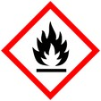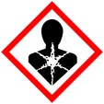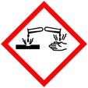

Procedure for fixing and embedding animal tissue with LR White for immunolocalization

**Protective Equipment**; Safety glasses, Lab coat, gloves and Chemical Fume hood

Remember to **label all vials** with; sample name, fixative type, your name & date

Fixation: 0.5 % - 1.5% Glutaraldehyde/2% Paraformaldehyde



in 0.1 M Phosphate or cacodylate buffer Overnight at 4 °C or 1 - 2 hr at rt

Rinse: 0.1 M buffer 3x 10 mins each

Dehydration:

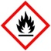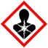

30 % Ethanol 10 mins

50 % Ethanol 10 mins

70 % Ethanol 10 mins

95 % Ethanol * 10 mins

Infiltration: :

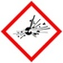

LR White : Ethanol (95% or 100%)

1 : 1 1 hr (optional step depends on sample density)

95 % or 100% LR White 3-4x 1 hr to overnight

Embedding:

LR White in gelatin capsules or other O2 excluding mold

- or use vacuum oven (check for correct temp (60 -65**°** C or 140 – 149**°** F)

Curing: Overnight in oven

*at this point you may continue on to 100% ethanol and then use 100 % ethanol in the mix with LR White