Cell Culture Fixation/Embedding - Epon

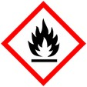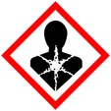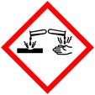

**Protective Equipment**; Safety glasses, Lab coat, gloves and Chemical Fume hood

Remember to **label all containers** with; sample name, fixative type, your name & date

Grow cells in well plate on Thermanox cover slips, observe sterile techniques.

Wash 3x in buffer *

Fixation: 2.5% Glutaraldehyde in 0.1 M buffer 1 h in well

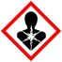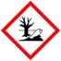

Rinse: With buffer* at the same concentration as fixative buffer 3x 10 mins each

Optional: Osmium tetroxide (1-2%) 1h room temp (r.t.),

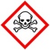

or overnight 4° C

Rinse: With ddH2O after OsO4 3x 5 -10 mins each

Dehydration: Before dhydrating, move cover slip carefully to scintillation vial

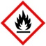

30% Ethanol 10 m

50% Ethanol 10 m

70% Ethanol 10 m

95% Ethanol 10 m

100% Ethanol 10 m each

Ethanol : Acetone

1:1 10 mins

100% Acetone 2x, 10 mins ea



Embedding: Acetone : Epon Mixture

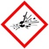

2 : 1 1 h

1 : 1 1 h

100% 2x, 1h

Fill mold with Epon and place cover slip cell-side down on resin, with edges of cover slip hanging over the edges of the mold.

Curing: 60º C overnight

Cover slip removal: Snap sample out of mold. Place sample, cover slip side down, on very hot hot plate. Peel sample off cover slip. If sample does not come off easily reheat.

* 0.1 M Phosphate buffer, PBS or Cacodylate

